HealthPro Bridge: What’s new v1.9

NEW FUNCTIONALITY
- Select multiple devices registered in the Managed table and delete them in bulk when they are in a state to be deleted.
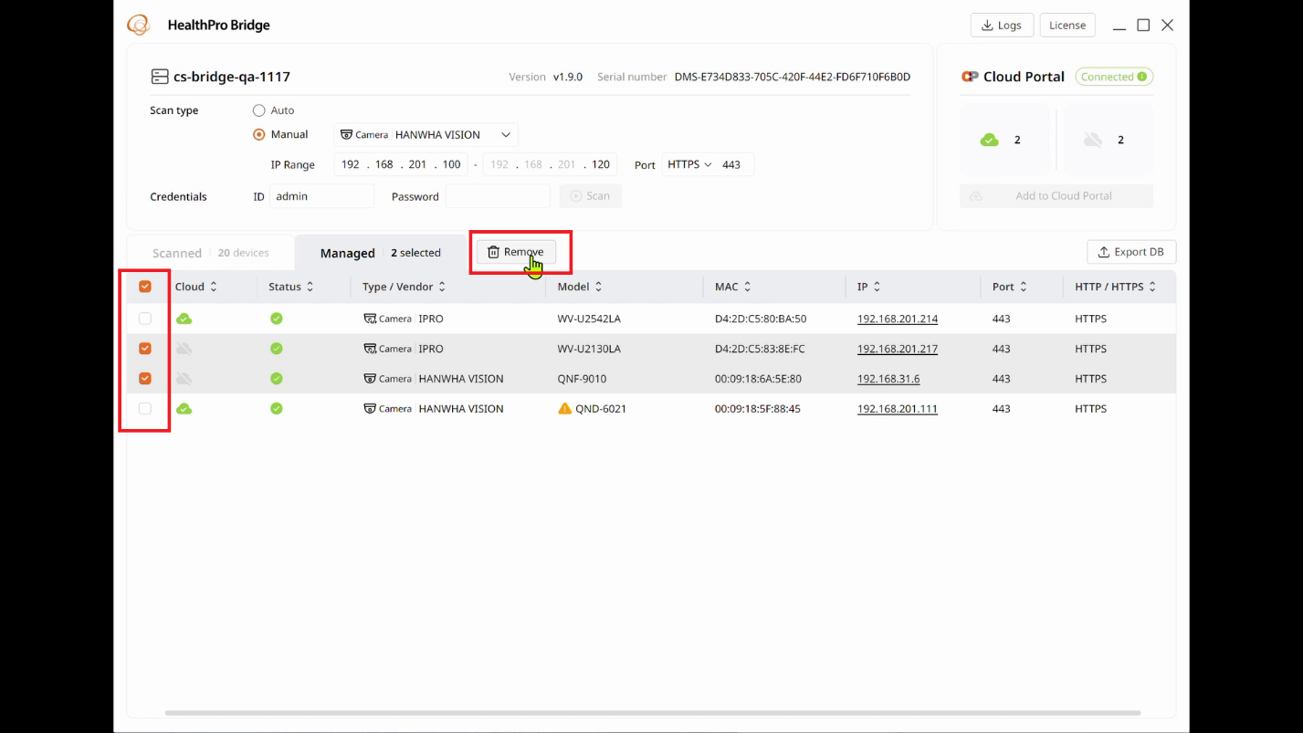
- Distinguish cameras with SUNAPI versions lower than 2.6.0 when claiming to the cloud.
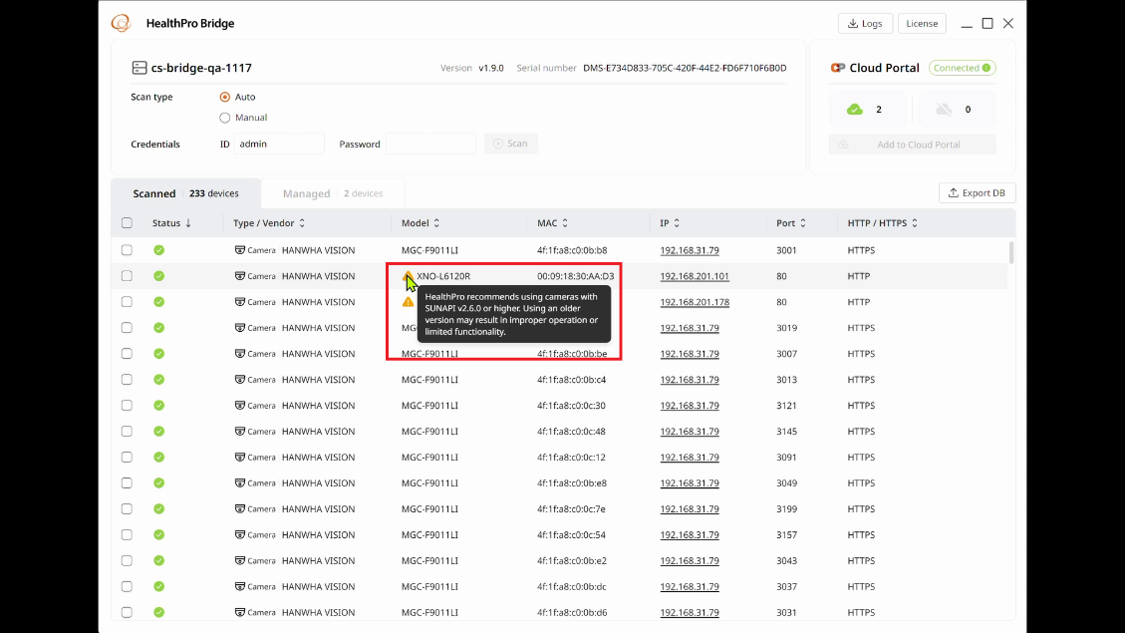
- Linux support. HealthPro Bridge now runs natively on Ubuntu 22.04 in addition to Windows.
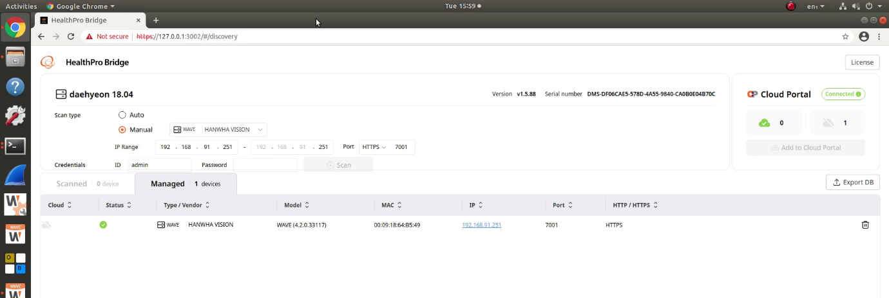
- Linux CLI. A command line interface is available for configuring and using a Linux HealthPro Bridge, however the web GUI is the recommended method.
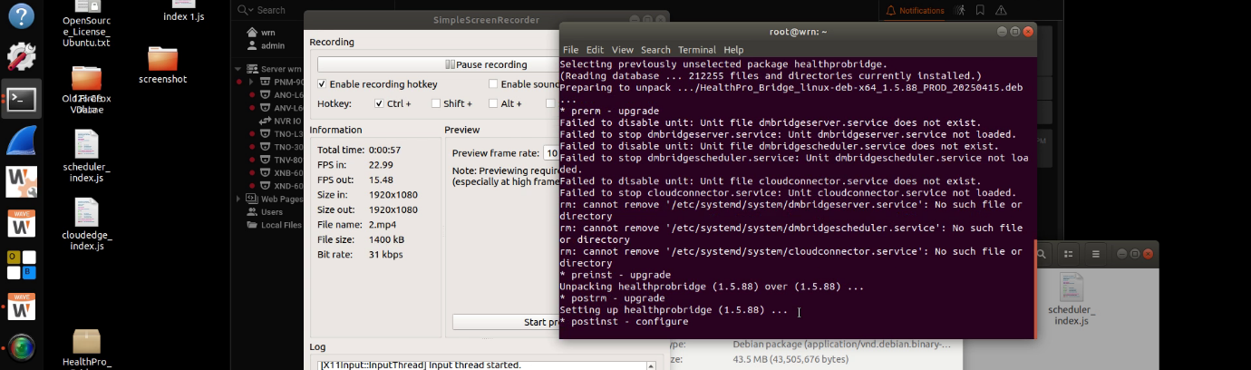
- HealthPro users can scan and add additional devices to HealthPro via the Cloud Portal when new devices are connected to a HealthPro Bridge's child WAVE server.

DEVICE COMPATIBILITY AND INTEGRATIONS
- HealthPro Bridge runs natively on Linux Ubuntu 22.04 as well as Windows.

- Scan and claim i-PRO and ONVIF cameras.
