HealthPro: What’s new v1.9

NEW FUNCTIONALITY
- Expand CSV export - location lists with expanded information, one package of the location-level dashboard, portal devices list in settings, target device management in the auto software update
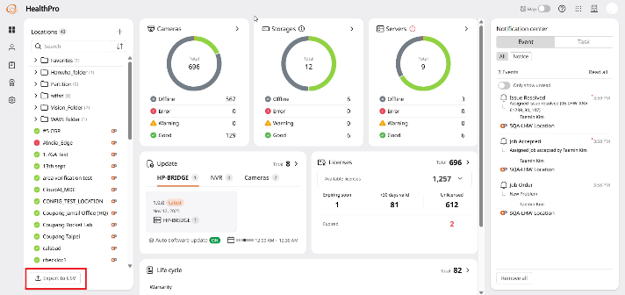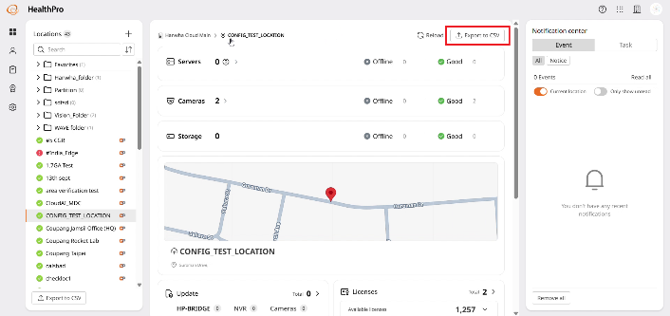
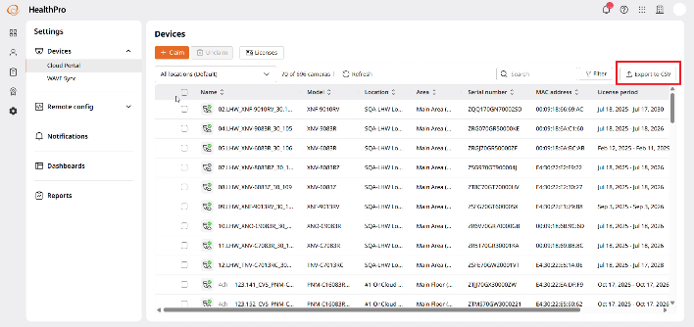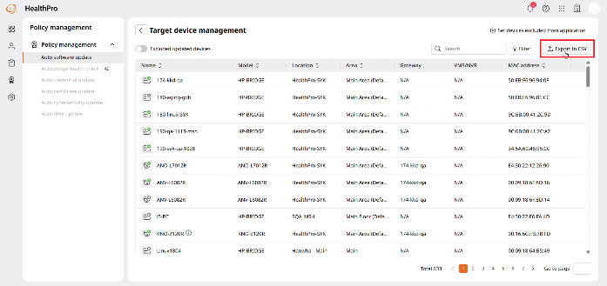
- HealthPro users can choose whether to delay task creation in the task creation options.
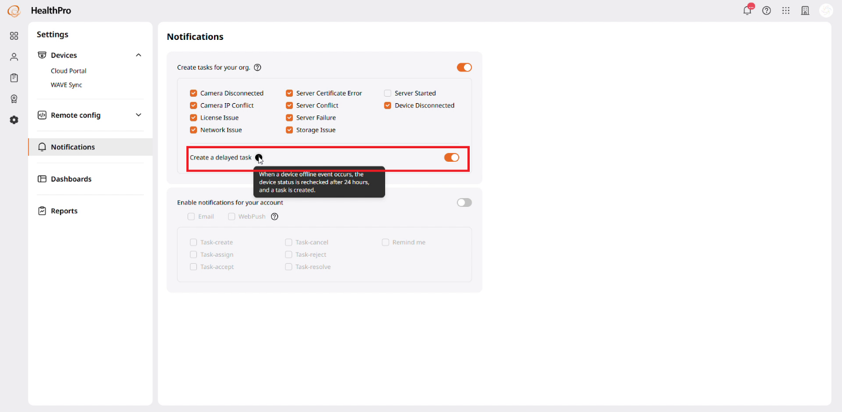
- HealthPro users can multi-select Good, Warning, Error, and Offline filters (tabs) on the server and camera dashboards (results included in CSV output).
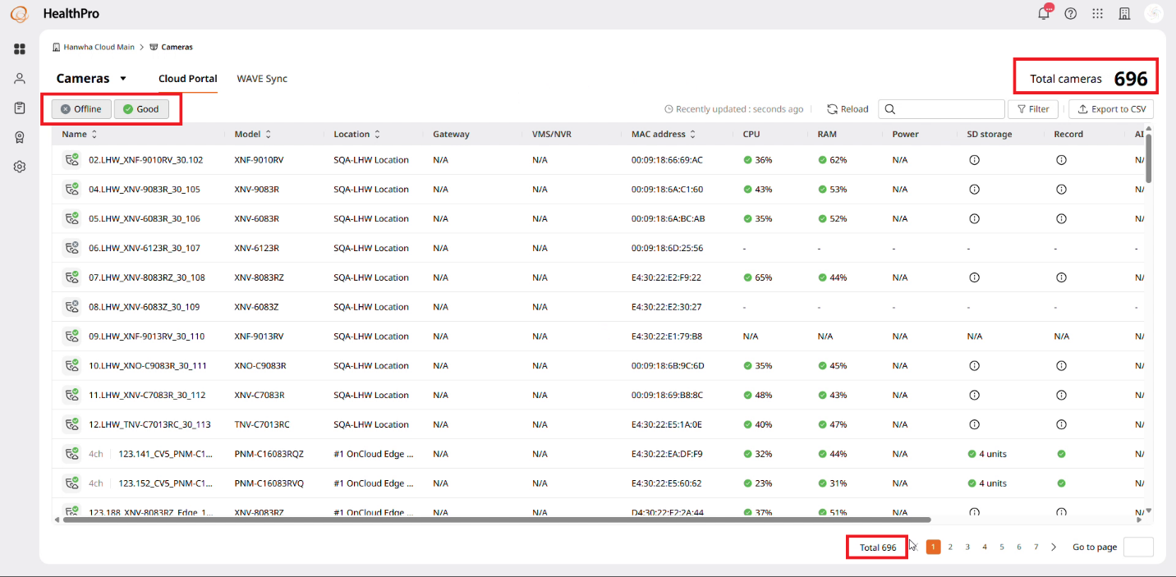
- HealthPro users can check the storage information of HealthPro Bridge in widgets and dashboards.
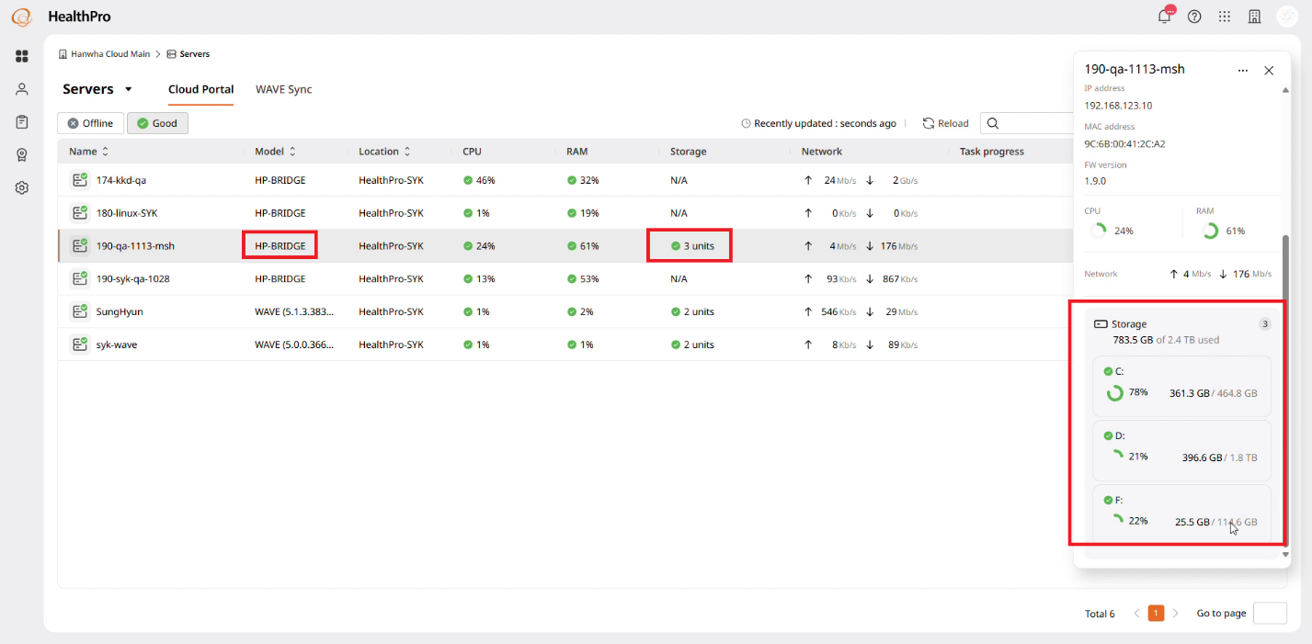
- HealthPro users can claim iPRO cameras and monitor health information through HealthPro Bridge.
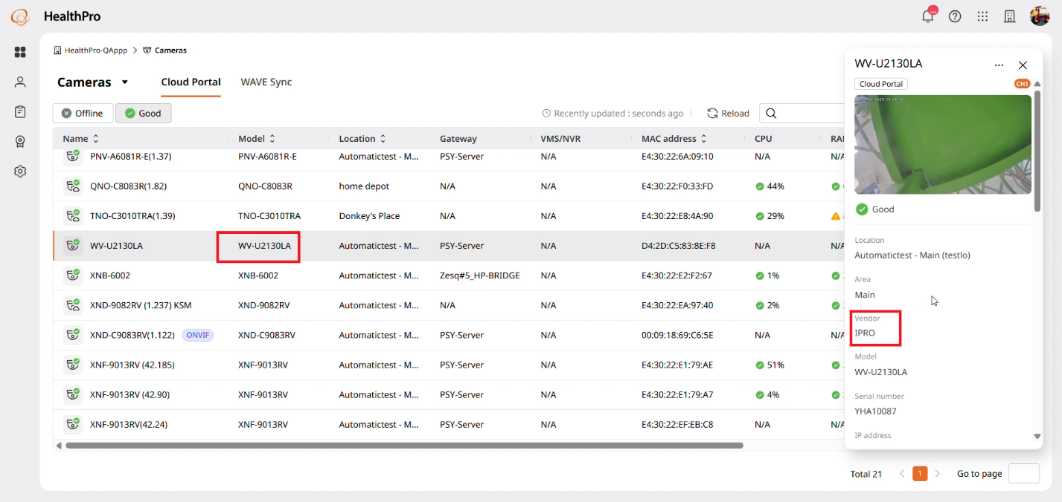
- Users designated in HealthPro can receive periodic system summary reports.
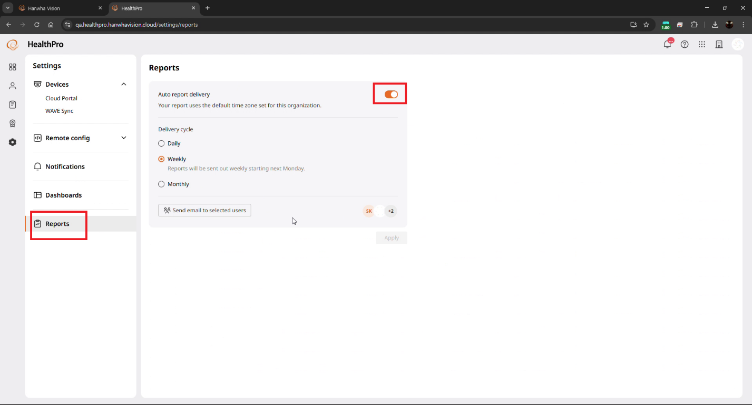
- When a HealthPro user changes the target device password through the password change function in Remote config, the target device password registered on the HPB-WAVE server is also updated.

- HealthPro users can claim Onvif cameras and monitor health information through HealthPro Bridge.
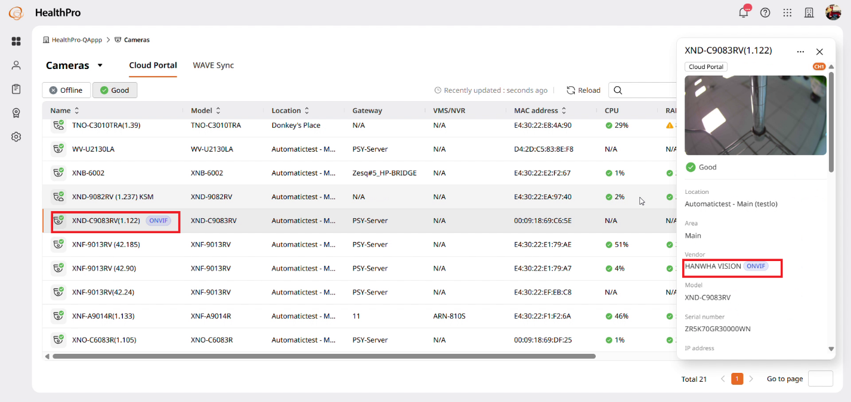
- HealthPro users can check HealthPro service availability via the Cloud Status webpage.
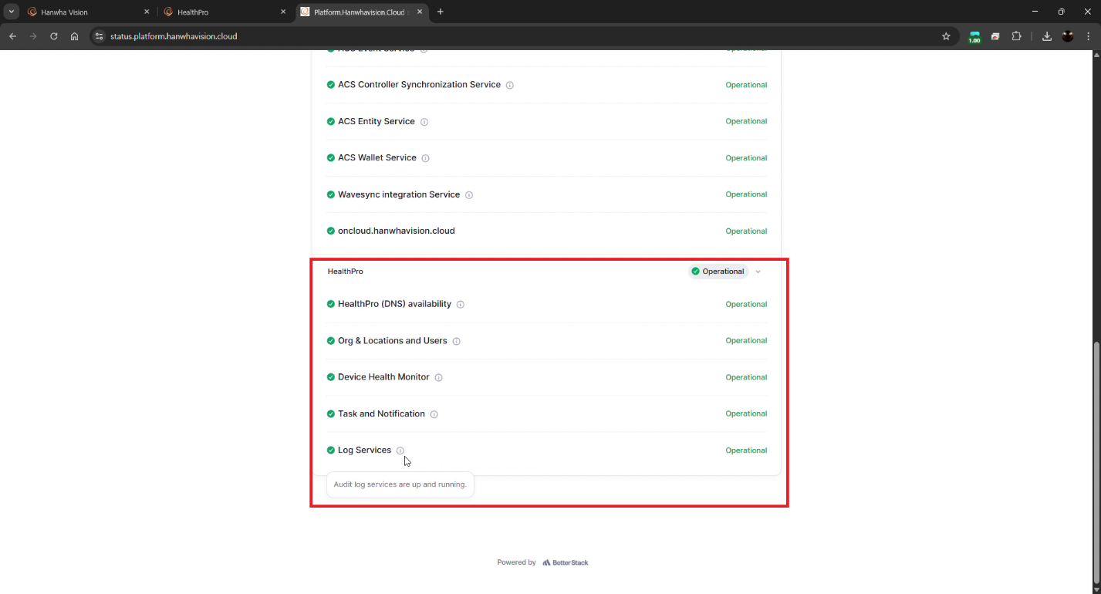
- HelathPro users can check all notices in real time in the notification center (event tab)
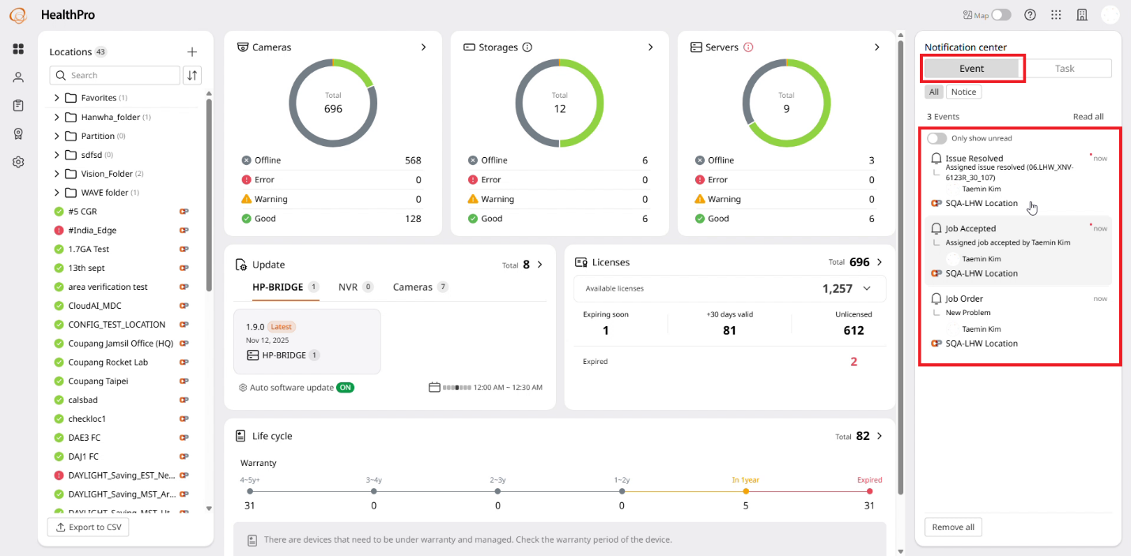
- HealthPro users can select devices to exclude from updates (firmware) based on criteria/groups (filter) rather than individual devices.
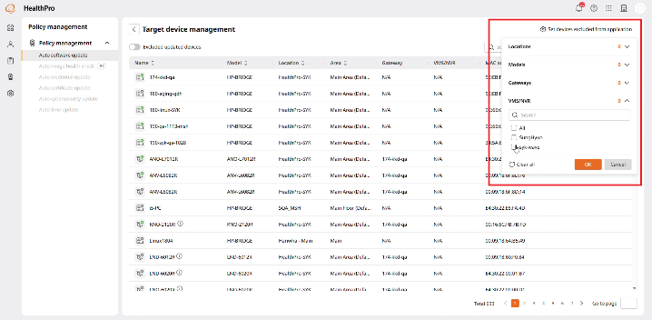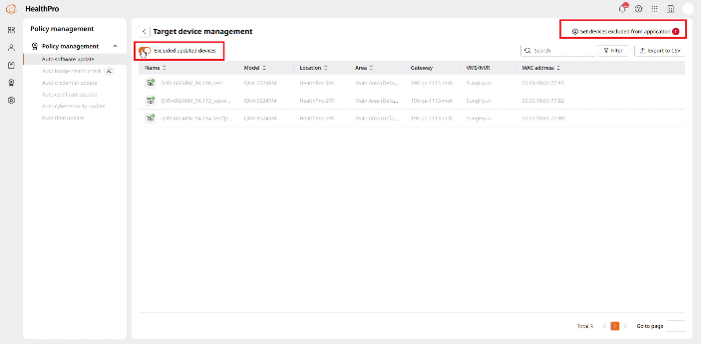
- Extending exclude from updating in auto firmware update to target device management feature.
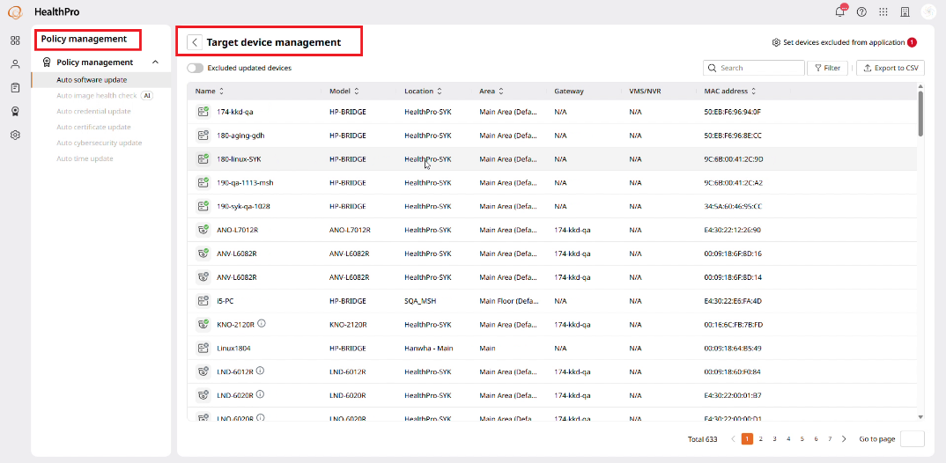
- HealthPro users can check real-time camera power consumption (W) through device details in the camera dashboard.
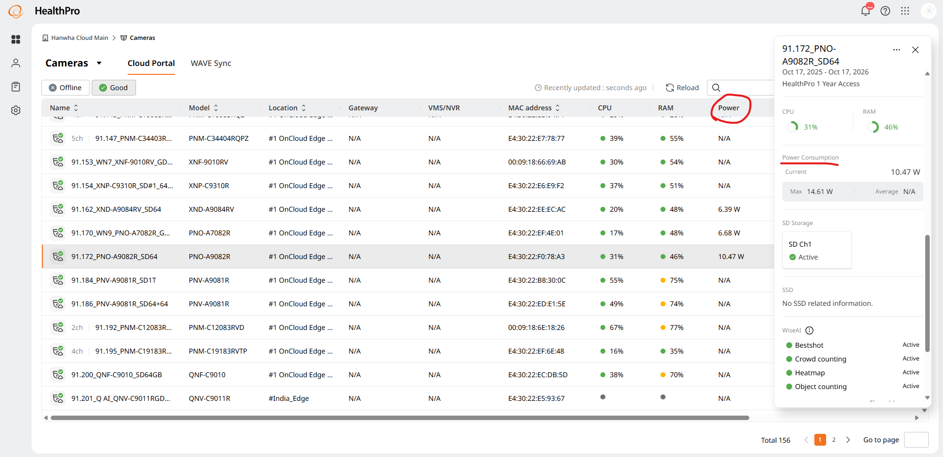
- HPB-WAVE users of HealthPro can immediately auto-synchronize the current WAVE server and sub-device (channel) names with the device names registered in the portal/HealthPro through the device name auto update function.

- All HealthPro users (customers + STEP partners) have access to key functions (menus) and locations controlled through HealthPro custom roles.
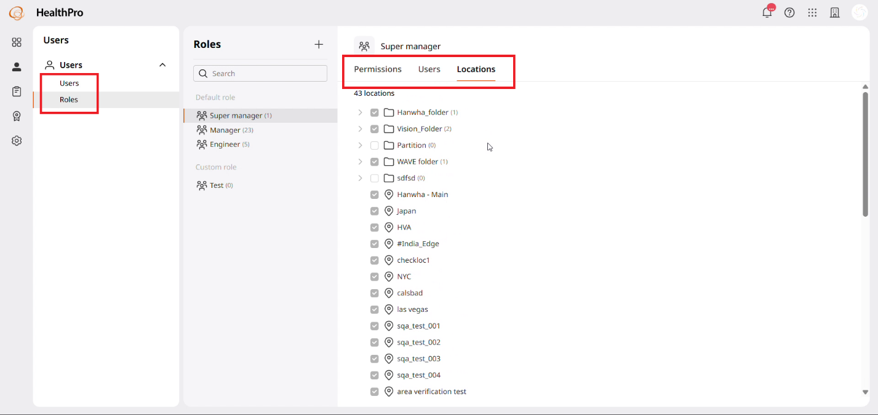
- HealthPro users can batch set the date and time within their devices through the Date and Time Settings feature in the remote config menu.
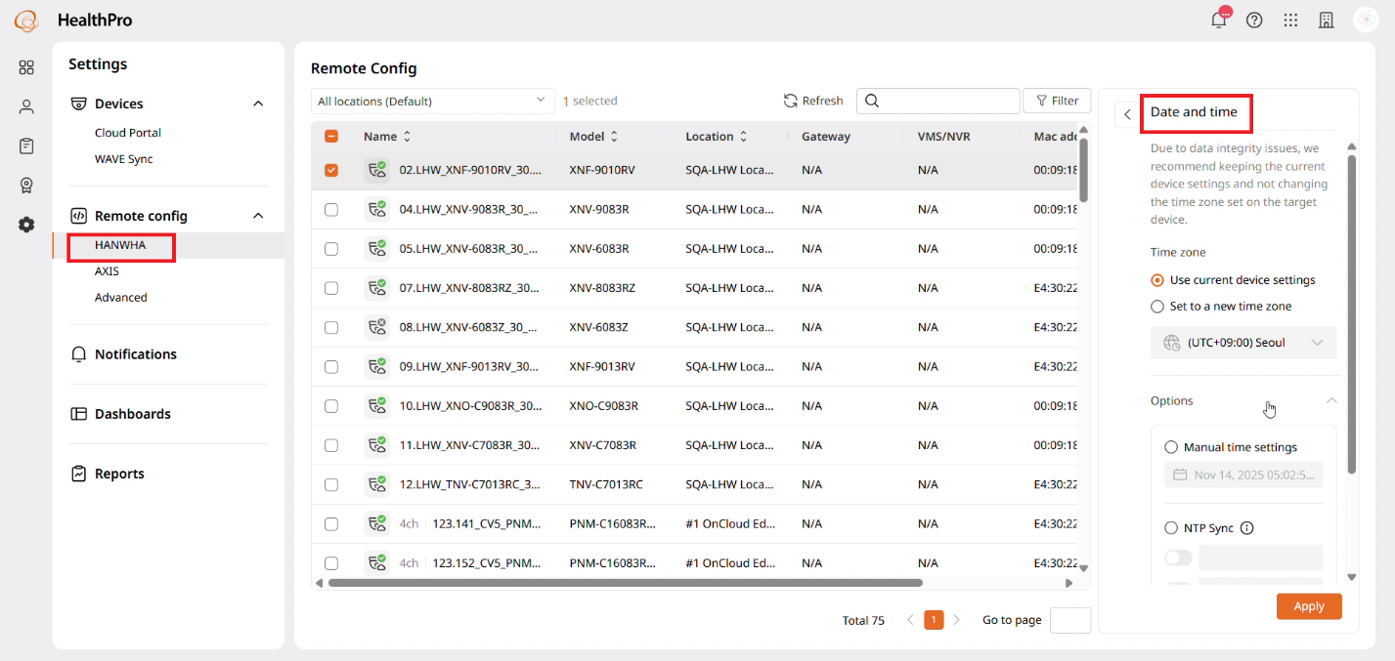
- HealthPro users can bulk attach new and used licenses (including individual attachments).
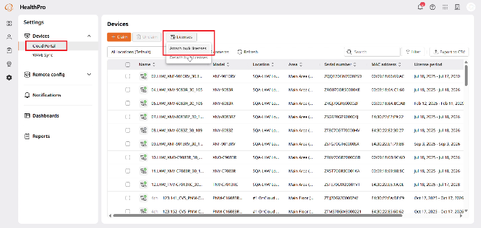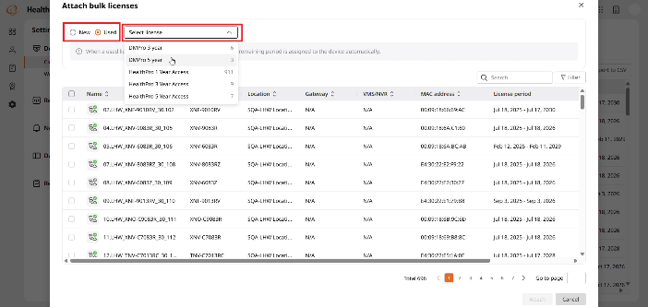
- HealthPro users can only view actual update target device information and quantity in the Update widget.
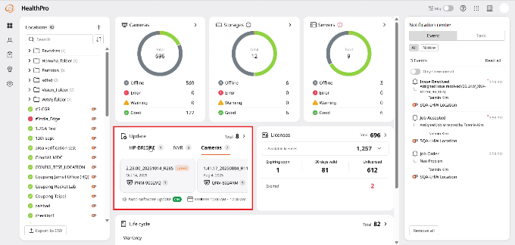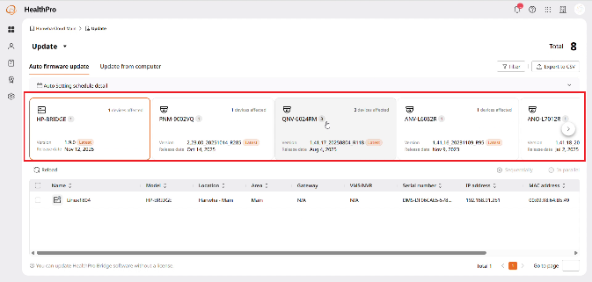
- Multi-Org support on the portal is also available to HealthPro users.
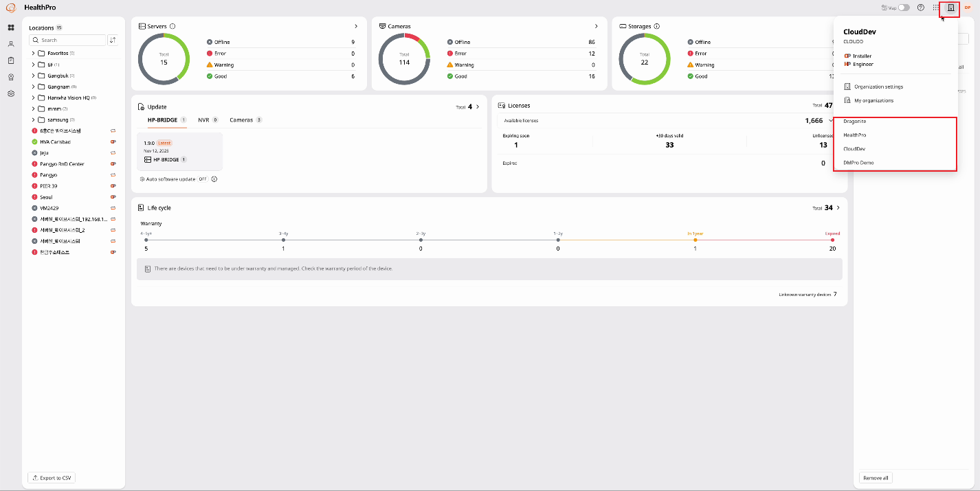
- Move the Policy Management icon to the main screen's location GNB and click to display the functions (menu) that will be provided.
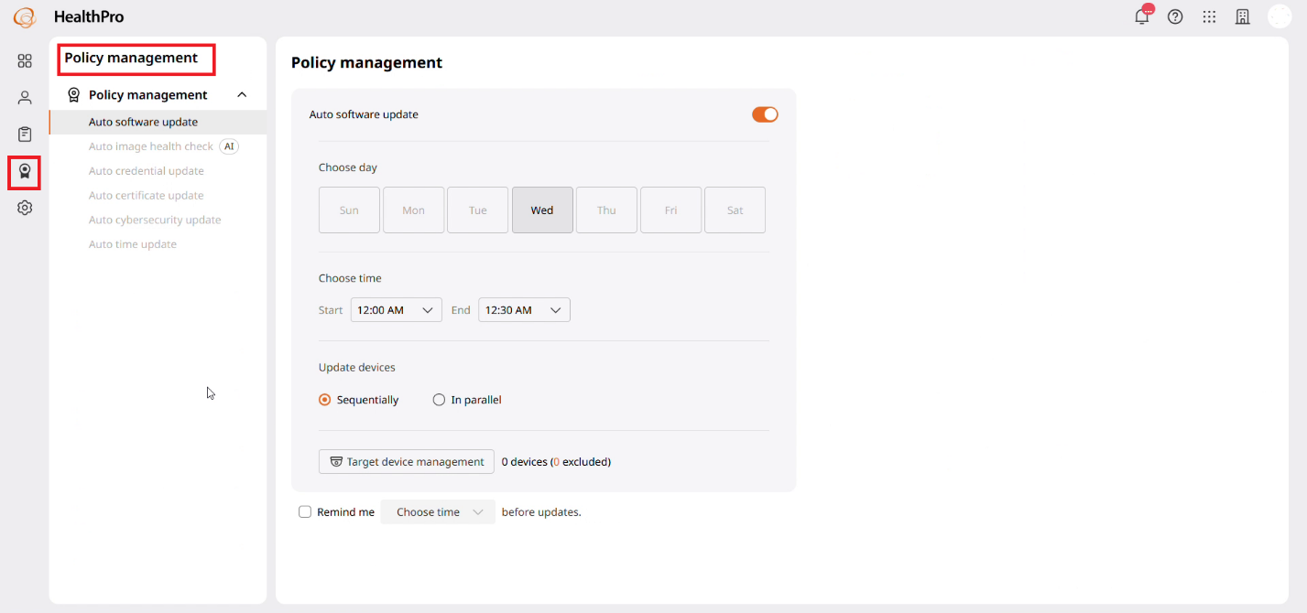
- HealthPro users who have connected their devices to the cloud via HealthPro Bridge can download HealthPro Bridge logs from HealthPro.
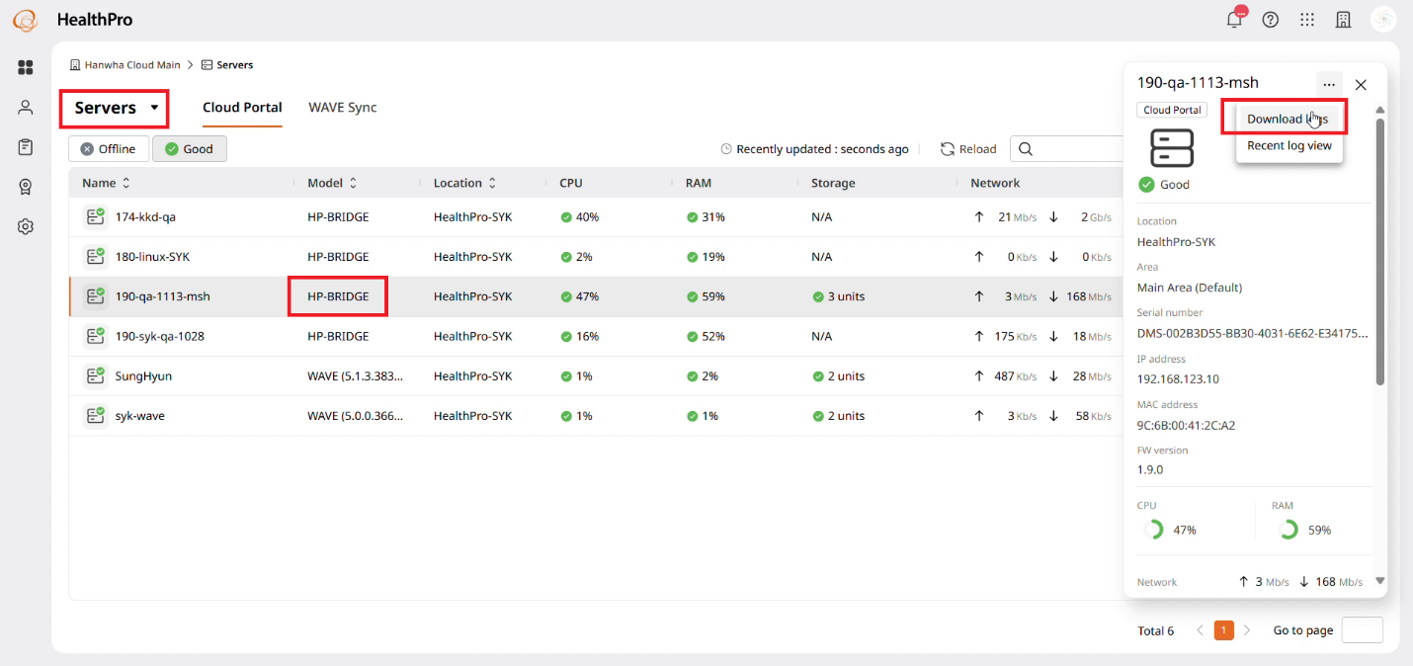
- HealthPro users can view recent device logs directly from the device details in the server and camera dashboards.
